LED Moving Zoom Bar
(LED-1260YZ)

USER MANUAL

Please keep read this manual carefully for further use!

Product introduction
Thank you for buying our professional LED Moving Zoom Bar light.
This user manual includes important information for installation and operation, so please read this user manual carefully before installation and operation, and keep this user manual well for further use.
In order to install , operate, and maintain the lighting safety and correctly. We suggest that the installation and operation should be done by the verified technician and follow the instruction strictly.
Spare part includes:
Name | QTY | Unit
Fixture | 1 | PC
User manual | 1 | PC
Power cable | 1 | PC
DMX cable | 1 | PC
Bracket Screw | 2 | PCS

Please check carefully that there is no damage caused by transportation. Should there be any, consult your local dealer.
Cautions
Before delivery, this device has passed strict inspection, Please follow the user manual strictly for operation, if this fixture is damaged by improper operation and mistake, the fixture will be out of warranty, and manufacture or dealer won’t be responsible for it. In case of any technology change in this manual,we won’t advise in further .



CAUTION!

Keep this device away from rain and moisture!

Unplug mains lead before opening the housing!

Warning!

Damages caused by the disregard of this user manual are not subject to warranty. The dealer will not accept liability for any resulting defects or problems.

Silkscreen symbol on light

------------------------------------------------------------------CE compliant
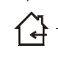
----------------------------------------------------------------Only indoor use

--------------------------------------------------------------RoHS Certificate
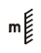
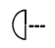
---------------The minimum distance from lighted objects(meter)

------- not suitable for direct installation on combustible material surface

1. Safety Instructions

- Please open and check whether break or not for transport once receive this fixture, if yes, don ‘t use it and contact dealer or manufacture as soon as possible.
- The Max applicable temperature for the light is 40°C. Do not use the light when the ambient temperature exceeds 40 degrees, ta=40℃
- The fixture is applicable for many occasions, please keep it clean, and avoid long use in overheating or dusty environment. To prevent the fixture from the chemical liquid .
- User must be careful of fire, heat, electric and fall-off that make heavy or fatal injury. Please read this user manual carefully before power on and installation, follow safety and operation instruction in it. If still have any question, please contact dealer or manufacture.
- User must follow this user manual, do not open fixture by yourself, if any problem, please contact professional technician, maintenance should be done by technician.
- Do not turn on the fixture before installation, please turn off the light after working more than 8 hours, which will prolong the lifespan of the fixture.
- During installation, prevent strong shocks or do not by strong shocks or vibration.
- The minimum distance between light and the illuminated surface must be more than 1 meter. 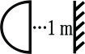
- Never look directly into the light source to avoid hurt to eyes (especially epileptics)!
- When dust proof glass at light output breaks, cracks or other visible damage, user should replace with new glass instead.
Warnings：please turn off the light before repair, maintenance or cleaning
2. Installation
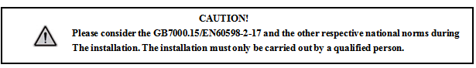

► This fixture is not suitable for direct installation on combustible material surface, please keep the fixture surface at least 0.5m from any combustible material.

► If you use the quick lock cam in hanging up the fixture, please make sure the quick lock fasteners turned in the quick lock holes correctly.
►The applicable temperature for the fixture is between -25°C to 45°C. Do not use the lighting under or above this temperature range.
►The truss for hanging the fixture should be able to hold 10 times weight of this fixture and no deformation after 1 hour hang.
►Please don’t stand under the fixture when install, uninstall, move or repair the fixture.
►Please ensure the light is connected correctly and invite professional technician to check and confirm the electrical data before installation.
►Please invite professional technician to check the fixture and installation each year
Rigging:
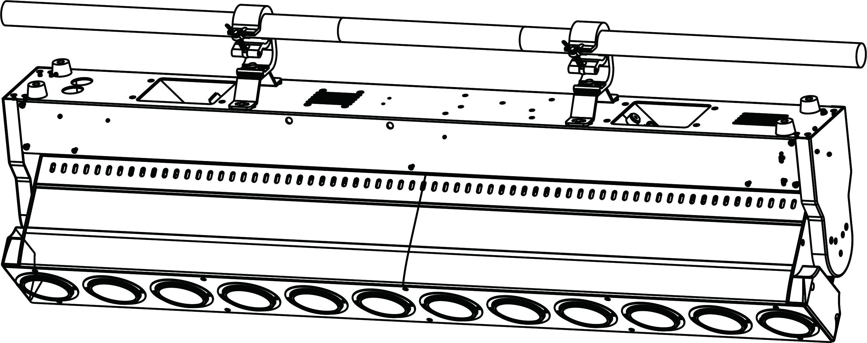

Install the quick-locking handle with the light hook on the fixing base plate : insert the quick-locking buckle into the two holes of the fixing plate and tighten the quick-locking buckle clockwise.
Clamp the installed lamp hook to the holder.
Pass the safety rope through a connecting hole in the center of the fixture base and hang it on the fixing bracket or another fixing point.
Note: This work is very important. As a second safety hanging device, it is guaranteed that the fixture body will not be dropped due to the problem of the light hook.

3. Product specification

12PCS 60W RGBW 4in1 LED；
LED lifespan:≥ 30000 hours
Input voltage：AC100 ~240V 50/60HZ
Power consumption： 680W
Beam angle:3--40º
Control mode：DMX,Auto,Sound
DMX channel：16/40/56 CH
IP rating: IP20
Display: 1.8-inch color LCD display, 180-degree rotatable
RGBW excellent color mixing effect, 0-100% smooth dimming
Signal input/output: 3 cores
Tilt: 220° (16bit precise scanning)
Maximum number of connections: 220V: within 8 units, the wire needs to be 2.5 mm²
120V: within 4 units, the wire needs to be 2.5 mm²
Product size: 1080*130*315 (mm)
Package size: 1160*210*420 (mm)
Net weight: 22kg
Gross weight: 24kg
Effect: LED point control, temperature control protection, overheating protection, high-efficiency cooling system, the fan can detect the temperature of the head of the light and automatically adjust the speed

- MENU Instruction
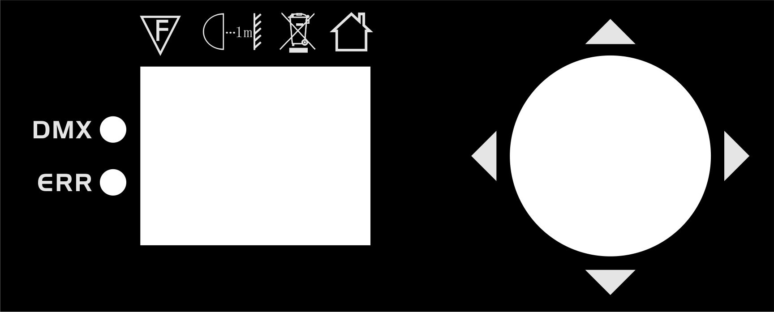

UP | Select the previous option
DOWN | Select the next option
ENTER | Confirm selected option
MENU | Enter menu, select option
“Left” | Display 180°reverse
Display operation
Main Menu | Secondary menu | Tertiary menu/parameter
DMX Address | 001 - 512
System setting | Operation Mode | DMX/Sound/Auto1/Auto2
System setting | Channel Mode | 16CH/56CH/40CH
System setting | Effect inversion | On/Off
System setting | Tilt inversion | On/Off
System setting | Hall Error Correction | On/Off
System setting | Optocoupler Error Correction | On/Off
System setting | Signal Hold | On/Off
System setting | Screen saver | On/Off
System setting | Screen Flip | On/Off/Auto
System setting | Synchronize Updates | On/Off
System setting | Language | CN/EN
System setting | Default | Confirm/Cancel
Manual Mode | Current Channel Mode | 0-255
System Calibration | Enter Password (No Password) | Light Calibration
System Reset | Effect Motor Reset
System Reset | Scan motor reset
System Reset | All motors reset
System information | Reset error information | Display reset error information
System information | DMX data monitoring | Receive the channel value of the console
System information | Sensor information | Hall information
System information | Sensor information | X optocoupler information
System information | Sensor information | Y optocoupler information
System information | Hardware version | Display the hardware version
System information | Software Version | Display the software version

- DMX channel

56CH | 40CH | 16CH | Function | Value | Description
1 | 1 | 1 | Tilt | 0-255 | 0-220°
2 | 2 | 2 | Tilt fine | 0-255 | 0-1.0°
3 | / | / | Tilt speed | 0-7 | Default speed
 |  |  |  | 8-247 | From slow to fast
 |  |  |  | 248-255 | Default speed
4 | 3 | 3 | Focus | 0-255 | Linear focus
/ | 4 | / | Reset | 0-255 | 101-160 motor reset
/ | 5 | / | LED1 dimmer | 0-255 | LED1 0-100% Linear dimming
5 | / | 4 | Dimmer | 0-255 | 0-100% Linear dimming
6 | / | 5 | Dimmer fine | 0-255 | 0-100% Linear dimming
/ | 6 | / | LED1 Strobe | 0-9 | No function
 |  |  |  | 10-130 | Pulse strobe from slow to fast
 |  |  |  | 131-255 | Regular strobe from slow to fast
7 | / | 6 | Strobe | 0-31 | No function
 |  |  |  | 32-63 | No function
 |  |  |  | 64-95 | Ordinary strobe: slow to fast
 |  |  |  | 96-127 | No function
 |  |  |  | 128-159 | Flash strobe: slow to fast
 |  |  |  | 160-191 | No function
 |  |  |  | 192-223 | Random strobe: slow to fast
 |  |  |  | 224-255 | No function
/ | 7 | / | LED1 Color | 0-8 | RGBW all on
 |  |  |  | 9-18 | R
 |  |  |  | 19-28 | G
 |  |  |  | 29-38 | B
 |  |  |  | 39-48 | RG
 |  |  |  | 49-58 | RB
 |  |  |  | 59-68 | GB
 |  |  |  | 69-78 | RW
 |  |  |  | 79-88 | RGB
 |  |  |  | 89-98 | W
 |  |  |  | 99-255 | Color Auto
/ | 8 | / | LED2 dimmer | 0-255 | LED2 0-100% Linear dimming
/ | 9 | / | LED2 strobe | 0-9 | No function
 |  |  |  | 10-130 | Pulse strobe from slow to fast
 |  |  |  | 131-255 | Regular strobe from slow to fast
/ | 10 | / | LED2 color | 0-8 | RGBW all on
 |  |  |  | 9-18 | R
 |  |  |  | 19-28 | G
 |  |  |  | 29-38 | B
 |  |  |  | 39-48 | RG
 |  |  |  | 49-58 | RB
 |  |  |  | 59-68 | GB
 |  |  |  | 69-78 | RW
 |  |  |  | 79-88 | RGB
 |  |  |  | 89-98 | W
 |  |  |  | 99-255 | Color Auto
/ | .... | / | ...... | ...... | ......
/ | 38 | / | LED12 dimmer | 0-255 | LED12 0-100% Linear dimming
/ | 39 | / | LED12 strobe | 0-9 | No function
 |  |  |  | 10-130 | Pulse strobe from slow to fast
 |  |  |  | 131-255 | Regular strobe from slow to fast
/ | 40 | / | LED12 color | 0-8 | RGBW all on
 |  |  |  | 9-18 | R
 |  |  |  | 19-28 | G
 |  |  |  | 29-38 | B
 |  |  |  | 39-48 | RG
 |  |  |  | 49-58 | RB
 |  |  |  | 59-68 | GB
 |  |  |  | 69-78 | RW
 |  |  |  | 79-88 | RGB
 |  |  |  | 89-98 | W
 |  |  |  | 99-255 | Color Auto
/ | / | 7 | Effect 1 | 0-8 | No effect
 |  |  |  | 9-38 | Running 1
 |  |  |  | 39-68 | Running 2
 |  |  |  | 69-98 | Running 3
 |  |  |  | 99-128 | Running 4
 |  |  |  | 129-158 | Running 5
 |  |  |  | 159-187 | Running 6
 |  |  |  | 188-255 | Running 7
/ | / | 8 | foreground color | 0-255 | Running foreground color
/ | / | 9 | background color | 0-255 | Running background color
/ | / | 10 | Effect 2 | 0-255 | Macro function effect: 0-9 no effect, and every ten values behind have an effect
/ | / | 11 | Speed | 0-255 | Effect speed from slow to fast
/ | / | 12 | R | 0-255 | Red from dark to bright
/ | / | 13 | G | 0-255 | Green from dark to bright
/ | / | 14 | B | 0-255 | Blue from dark to bright
/ | / | 15 | W | 0-255 | White from dark to bright
8 | / | 16 | Reset | 0-100 | No function
 |  |  |  | 101-160 | Motor reset
 |  |  |  | 161-255 | No function
9 | / | / | LED1R | 0-255 | LED1 Red dimming from dark to bright
10 | / | / | LED1G | 0-255 | LED1 Green dimming from dark to bright
11 | / | / | LED1B | 0-255 | LED1 Blue dimming from dark to bright
12 | / | / | LED1W | 0-255 | LED1 White dimming from dark to bright
13 | / | / | LED2R | 0-255 | LED2 Red dimming from dark to bright
14 | / | / | LED2G | 0-255 | LED2 Green dimming from dark to bright
15 | / | / | LED2B | 0-255 | LED2 Blue dimming from dark to bright
16 | / | / | LED2W | 0-255 | LED2 White dimming from dark to bright
.... | / | / | ...... | ...... | ......
53 | / | / | LED12R | 0-255 | LED12 Red dimming from dark to bright
54 | / | / | LED12G | 0-255 | LED12 Green dimming from dark to bright
55 | / | / | LED12B | 0-255 | LED12 Blue dimming from dark to bright
56 | / | / | LED12W | 0-255 | LED12 White dimming from dark to bright

6. DMX-512 connection

Connect the provided XLR cable to the male 3-pin XLR output of your controller and the other side to the female 3-pin XLR input of the light.then connect the DMX signal to the first fixture to the 2nd fixture, after all fixtures are connected,

The signal cable should be two - core with screened cable with XLR input and output connectors. Please refer to the diagram below.

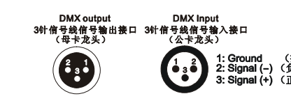

3-Pin DMX output 3-Pin DMX input
1. Ground
2. Signal -
3.Signal +
DMX terminator connection
If there are many lines or lights, it is recommended to use a DMX terminator to prevent DMX signal corruption, the DMX terminator is an simple XLR plug with a 120 Ω resistor connected between pins 2 and 3,which is then plugged into the output XLR socket of the last fixture in the chain.
7.DMX address setting

Each fixture must set a specific starting address. When receiving signal, fixture will receive channel control signals of this address from the DMX controller.
For easy to use, the user can set the same address for several fixtures , also can set up a unique address for every device.
If you set the same address for all fixtures, all the fixtures will receive from the same DMX channels signal. All connecting fixtures are jointly controlled, controller can't separately control a device.
If you set a different address for each fixture, each fixture will receive unique signal and can be controlled by DMX controller separately.
This fixture has 16/40/56 channels.you should set the starting address of the first unit to 1, the second unit to 17(16 + 1)/41(40+1)/57(56 + 1) , the third unit to 33（16+17）/ 81(40=41)/113(56+57), and so on.

DMX ID: 33 /81/113 DMX ID: 17 /41/ 57 DMX ID: 1

8. Cleaning and maintenance

Cleaning should be performed every 15-day period, by using a sponge which is dipped with alcohol, rather than wet cloth or other chemical liquid, to clean the mirror.

Cut off power before cleaning and maintenance!
CAUTION

Attention

Do not see directly light source when open the light, and make sure power off before do any installation or maintenance.

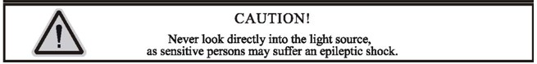

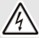 Wires connection must be done professional person!
CAUTION

Warranty Card
This product is made of high-brightness transistor. We will provide 1 year warranty under the condition that user has operated the light normally and lifetime service. We won't provide warranty if the damage is caused by artificial or force majeure event. Cost of fittings should be charged by user if product need maintenance after 1 year .Please cut this warranty card and shipped it along with the product to our factory when applying for warranty.
Product： Purchasing date： Code of invoice：
Warranty date: From To
User’s name： Add：
Company： Tel：

